Lab 05 : Django
Arhaan Girdhar – 220962050

Q2. Create a web form which allows the teacher to enter the student details like name,
date of birth, address, contact number, email id and marks of English, Physics and
Chemistry. After filling all the information and on clicking submit button, details
should be added to a textarea displayed on the same page. Display the total
percentage of marks obtained in a label.

urls.py

from django.urls import path
from . import views

urlpatterns = [
path('', views.student_form_view, name='student_form'),
]

views.py

from django.shortcuts import render
from .forms import StudentForm

def student_form_view(request):
form = StudentForm()
last_percentage = None

if 'student_entries' not in request.session:
request.session['student_entries'] = []
entries = request.session.get('student_entries')

if request.method == 'POST':
form = StudentForm(request.POST)
if form.is_valid():

name = form.cleaned_data['name']
date_of_birth = form.cleaned_data['date_of_birth']
address = form.cleaned_data['address']
contact_number = form.cleaned_data['contact_number']
email = form.cleaned_data['email']
english_marks = form.cleaned_data['english_marks']
physics_marks = form.cleaned_data['physics_marks']
chemistry_marks = form.cleaned_data['chemistry_marks']

total_marks = english_marks + physics_marks + chemistry_marks
percentage = (total_marks / 300) * 100
last_percentage = round(percentage, 2)

entry = (
f"Name: {name}\n"
f"DOB: {date_of_birth}\n"
f"Address: {address}\n"
f"Contact: {contact_number}\n"
f"Email: {email}\n"
f"English: {english_marks}, Physics: {physics_marks}, Chemistry: {chemistry_marks}\n"
f"Percentage: {last_percentage}%\n"
"----------------------\n"
)

entries.append(entry)
request.session['student_entries'] = entries
form = StudentForm()

context = {
'form': form,
'entries': ''.join(entries),
'last_percentage': last_percentage,
}

return render(request, 'students/student_form.html', context)

forms.py

from django import forms

class StudentForm(forms.Form):
name = forms.CharField(max_length=100, label='Name')
date_of_birth = forms.DateField(
widget=forms.DateInput(attrs={'type': 'date'}),
label='Date of Birth'
)
address = forms.CharField(
widget=forms.Textarea(attrs={'rows': 3}),
label='Address'
)
contact_number = forms.CharField(max_length=15, label='Contact Number')
email = forms.EmailField(label='Email ID')
english_marks = forms.IntegerField(min_value=0, max_value=100, label='English Marks')
physics_marks = forms.IntegerField(min_value=0, max_value=100, label='Physics Marks')
chemistry_marks = forms.IntegerField(min_value=0, max_value=100, label='Chemistry Marks')

student_form.html

<!DOCTYPE html>
<html lang="en">
<head>
<meta charset="UTF-8">
<title>Student Details Form</title>
<style>
body {
font-family: Arial, sans-serif;
padding: 20px;
}
.form-container {
max-width: 600px;
margin: 0 auto;
}
label {
display: block;
margin-top: 10px;
}
input, textarea, select {
width: 100%;
padding: 8px;
margin-top: 5px;
box-sizing: border-box;
}
.submit-button {
margin-top: 15px;
padding: 10px 15px;
background-color: #3498db;
color: white;
border: none;
cursor: pointer;
}
.submit-button:hover {
background-color: #2980b9;
}
.result {
margin-top: 20px;
}
.percentage-label {
font-weight: bold;
}
textarea {
height: 200px;
resize: none;
}
</style>
</head>
<body>
<div class="form-container">
<h1>Enter Student Details</h1>
<form method="post">
{% csrf_token %}
{{ form.as_p }}
<button type="submit" class="submit-button">Submit</button>
</form>

{% if last_percentage %}
<div class="result">
<label class="percentage-label">Total Percentage: {{ last_percentage }}%</label>
</div>
{% endif %}

<div class="result">
<label for="entries">Student Details:</label>
<textarea id="entries" readonly>{{ entries }}</textarea>
</div>
</div>
</body>
</html>

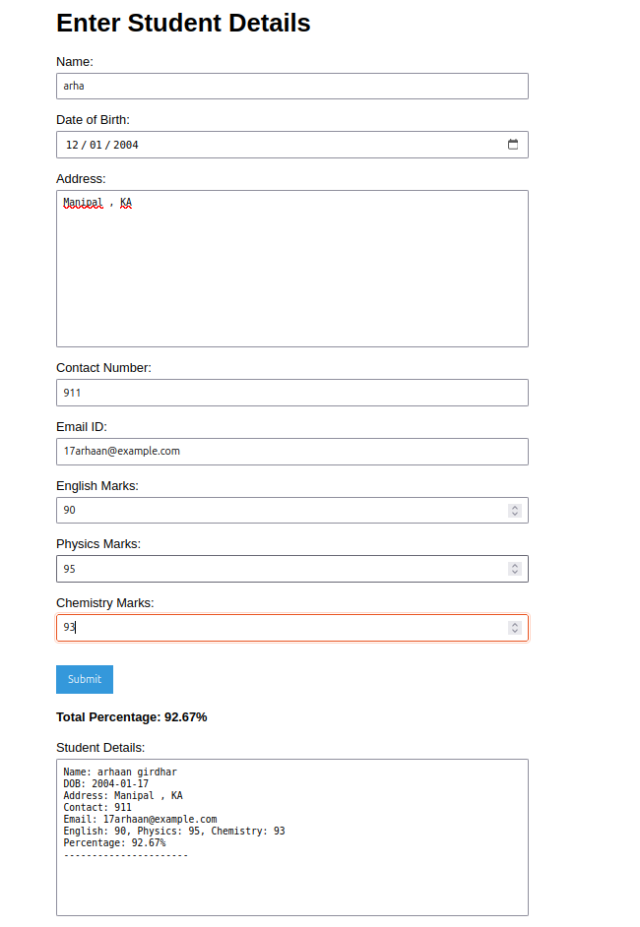

Q2. Create a web form with employee ids in dropdown list. Use a textbox for accepting
date of joining. Add a button named “Am I Eligible for Promotion”. On clicking
the button, if he has more than 5 years of experience, then display “YES” else
“NO” in the label control.

urls.py

from django.contrib import admin
from django.urls import path, include

urlpatterns = [
path('admin/', admin.site.urls),
path('', include('employee.urls')),
]
views.py

from django.shortcuts import render
from datetime import date
from .forms import PromotionForm

def promotion_check_view(request):
result = ""
if request.method == "POST":
form = PromotionForm(request.POST)
if form.is_valid():
doj = form.cleaned_data['date_of_joining']
today = date.today()
years_experience = today.year - doj.year - ((today.month, today.day) < (doj.month, doj.day))
result = "YES" if years_experience > 5 else "NO"
else:
form = PromotionForm()
context = {'form': form, 'result': result}
return render(request, 'employee/promotion_form.html', context)

forms.py

from django import forms

EMPLOYEE_CHOICES = [
('emp1', 'Employee 1'),
('emp2', 'Employee 2'),
('emp3', 'Employee 3'),
]

class PromotionForm(forms.Form):
employee_id = forms.ChoiceField(choices=EMPLOYEE_CHOICES, label="Employee ID")
date_of_joining = forms.DateField(widget=forms.DateInput(attrs={'type': 'date'}), label="Date of Joining")

manage.py
#!/usr/bin/env python
import os
import sys

def main():
os.environ.setdefault('DJANGO_SETTINGS_MODULE', 'employee_promotion_project.settings')
from django.core.management import execute_from_command_line
execute_from_command_line(sys.argv)

if __name__ == '__main__':
main()

wsgi.py

import os
from django.core.wsgi import get_wsgi_application

os.environ.setdefault('DJANGO_SETTINGS_MODULE', 'employee_promotion_project.settings')
application = get_wsgi_application()

form.html

<!DOCTYPE html>
<html>
<head>
<meta charset="UTF-8">
<title>Promotion Eligibility Check</title>
<style>
body {
font-family: Arial, sans-serif;
padding: 20px;
}
form {
margin-bottom: 20px;
}
label, select, input {
display: block;
margin-bottom: 10px;
}
button {
padding: 10px 15px;
background-color: #3498db;
color: #fff;
border: none;
cursor: pointer;
}
button:hover {
background-color: #2980b9;
}
.result {
font-size: 1.2em;
font-weight: bold;
}
</style>
</head>
<body>
<h1>Check Promotion Eligibility</h1>
<form method="post">
{% csrf_token %}
<div>
{{ form.employee_id.label_tag }}
{{ form.employee_id }}
</div>
<div>
{{ form.date_of_joining.label_tag }}
{{ form.date_of_joining }}
</div>
<button type="submit">Am I Eligible for Promotion</button>
</form>
{% if result %}
<div class="result">Eligibility: {{ result }}</div>
{% endif %}
</body>
</html>

